Gardening to
Support Butterflies and Other Pollinators

Creating Interest and Intensity (and food quality!)
in the Perennial and Annual Garden

RULE # 1: RESTRICT OR ELIMINATE
THE USE OF ALL PESTICIDES IN YOUR YARD.
THIS INCLUDES THE LAWN!

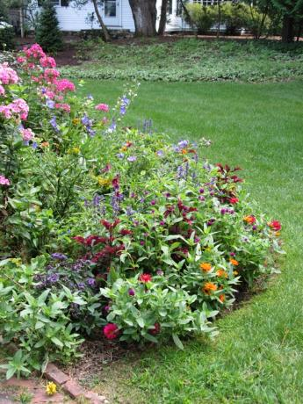
And now that you’re not using pesticides…
you’ll need to learn how to grow super healthy plants even if they’re “ONLY” flowers! Healthy flowers last longer when cut and really boost the health of the insects that use them for food. Look to the quality of your soils – they’re the backbone of anything you’re doing in your yard. That’s a topic on its own but well worth looking into – think about adding a soil test to your to-do list.

Now on to the fun part of designing the garden that will appeal to you and to your winged visitors…

Everyone looks at the colors of flowers. That’s what we’re supposed to respond to! Read Michael Pollan. Many people start their garden planning by deciding where a garden might fit in their yard and lifestyle and then going to the local garden center and buying one of anything that catches their eye. Sound like you?!? Everyone does it! Even people who “should know better” – like me! For people who like plants, it’s almost impossible not to – the kid in the candy store syndrome. The problem is that a plant purchase usually can’t be eaten to be dealt with! Once purchased, it needs to find its way into some sort of garden setting in order to survive and thrive. This is where problems can develop.

We’ll take a quick look at the human perspective and then move on to the other garden visitors.

Here are two basic concepts to keep in mind that will help to create a dynamic garden that works for butterflies, bees and beneficial bugs as well as its human creator and caretaker.

- Groups of 3 and/or 5 plants should be the foundation of all but the smallest garden. This provides the visual weight that is often lacking in gardens that develop from those trips to the garden center! Plant groups of 7 add real visual weight and can act as signals and beacons to butterflies, bees and hummingbirds.
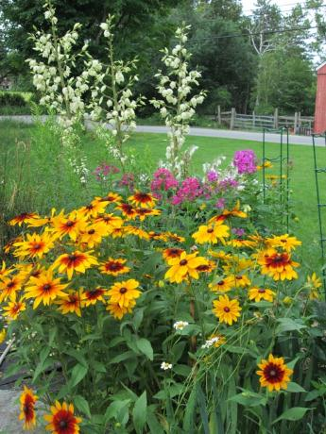
2. Look at the kind of flower that the plant has.
Flowers can be generally described as “spikes” – think Delphinium and Lupines, “flats” – think the whole daisy clan, and “cups” or “irregulars” – think tulips and peonies. The best gardens use a combination of flower types that bloom at the same time. This helps to explain why the classic combination of peony, delphinium and Shasta daisy works for human aesthetics. The neat thing is that mixing up the types of flowers brings in lots of different kinds of good guy insects.

And now for the flying visitors…Here are some of the basic considerations for encouraging birds and butterflies to live in your yard.

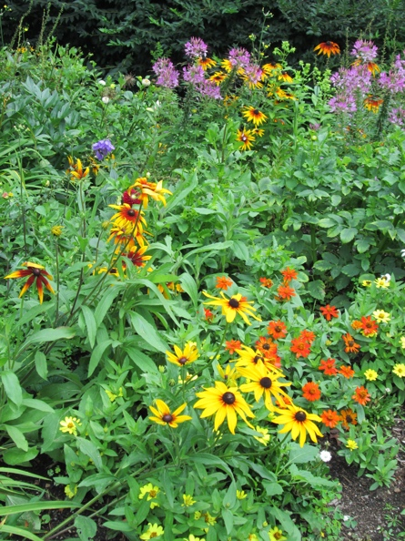
Use the design considerations above and add specific species information to your decisions – an example would be yarrow (Achillea sp.). A classic perennial that loves hot dry soils, has a flat flower and ferny foliage, lasts as a cut flower and brings in lady bugs, lacewings, parasitic wasps etc. A true win/win.

There are lots and lots of lists of plants that are fantastic at supporting insects. Take the time to learn about a species and discover its secrets. Can I suggest one of my personal favorites??? The bumblebee! Have you ever just stopped and watched these ladies - and they’re always ladies - work? Try it this summer… If you can’t wrap your mind around a “stinging” insect then how about a praying mantis – they’re big enough to be seen easily – and will eat ANY insect (“good” or “bad”) that they can catch – still worth watching though! And then there’s the Monarch butterfly – that is under huge pressure but may survive now that humans are paying a bit of attention…..

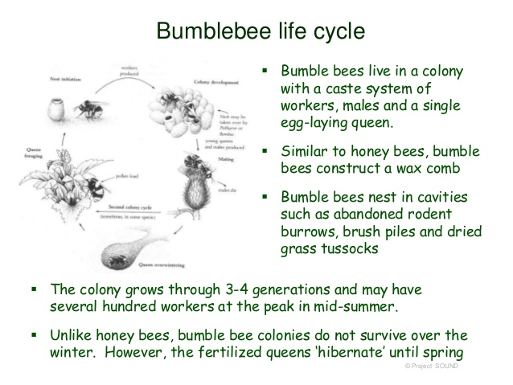
As with all animals though – food and water are your best means of enticing them to visit your yard. Let’s start with food – for the adults for now. Most of the good guys need pollen and nectar to support the adult stages (obviously not true of all!!) and this is the most fun for us because this is the flowers that we love as well. There are lots of lists of course but think color (red, orange, yellow, blues) and think about flat forms (daisies and zinnias), tubular forms (columbine, salvias), and “umbelliferae” forms like fennels,
Queen Anne’s Lace and dills. Include a few larger plantings of desirable flowering plants (such as salvia, torch plant or butterfly bush etc.). It's easier for both the birds and the butterflies to find a mass planting. Consider researching woody plants like trees and shrubs that provide flowers early and late (like Maples and Witch Hazels)

If you really get going on this habitat development gig – then look up what feeds the youngsters. Bees are easy because the nectar and pollen that feed the adults feed the young. Monarchs, on the other hand, can feed on a wide range of flowers as an adult but can only survive and thrive as caterpillars on milkweeds (Asclepias) – and have to be true milkweeds – not the look alikes (and close relatives) like swallowwort (hateful plant…)
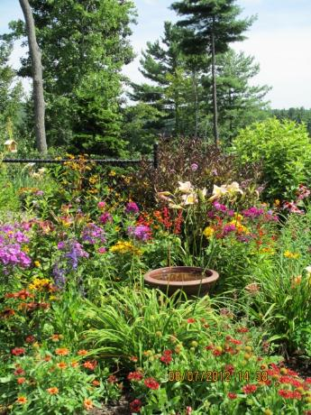
Think of your yard as a series of layers. Design the layers so that you can see the birds and the butterflies and so that they can see their predators. Include a few larger plantings of desirable flowering plants (such as salvia, torch plant or butterfly bush etc.). It's easier for the insects to find a mass planting. Create an area where there is moving water with a shallow edge where they can creep down for moisture without drowning.

You can totally disrupt native pollinators and other beneficial insects by cleaning your gardens up too early – before the first flowering shrubs start to bloom (often Cornus mas and Hamamelis japonica - Japanese witch hazel – but also the well known Acer rubrum - red swamp maples). The native insects often winter in the debris left in your garden and woodland edges and have not emerged if there are no flowers in their extended neighborhood - a manicured and well-maintained yard is not the best place for birds and butterflies. You may remove pupae of desirable butterflies and food and nesting materials for the birds. Consider planting clump grasses and leaving them up for the winter as protection –then wait to clean them down until AFTER the local red maples have started blooming – that’s the start of the biological season for native pollinators etc.

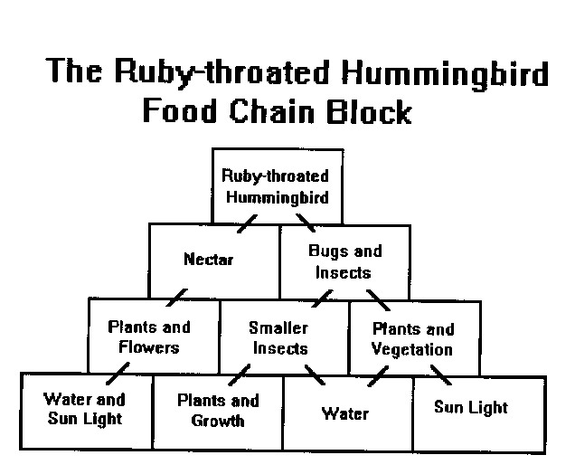
Manmade feeders can be used for many species of birds and butterflies. Feeders include nectaries, seed dispensers, protein and fat dispensers (suet and peanut butter) and mineral salt licks. Hummingbirds will use a mix of 1-part white sugar (no honey!) dissolved into 4 parts water. Mealworms and chopped hard-boiled egg can be left out for birds during the time when they feed their young.

M.L. Altobelli
The Good Earth Farm and Garden Center Altobelliml260@comcast.net
https://www.thegoodearthfgc.com

